**Ping Project Proposal**

**Pitch**

Most college students locate one another via SMS or social media. Want to grab lunch with a friend? Text them and see if they're at Foco. Want to figure out who's at a social event? GroupMe out and ask if there's a scene. But all of these things take effort, and even with so many means of communication it's hard to figure out where people are at any given time. Wouldn't it be nice if an application could streamline the process of finding colleagues on campus?

Ping does this and more. It’s a location based social media application that not only allows users to find their friends, but also lets people see what’s going on around them. Think Apple's Find My Friends app mixed with Yik Yak. There are two ways to use the application: active and passive.

*Active*: Users can post anonymously to describe where they are and what they’re doing. Think “the line at Foco is absurd” or “this bar is bumpin” attached to a location, which can be seen by others in some predefined radius. Users can send their friends push notifications containing their location, optionally with a message. Think “come over later, we’re having a small get together” or “we’re eating on the green, come join!” Users can also query friends to ask for their current locations.

*Passive*: Logging into the application presents a UI where users will see the anonymous posts of people in their general area. You can also view a "heat map" of who is where nearby. Users who choose to share their location anonymously show up as numbers within a geofenced area.

Ping would also be able to provide support for people who find themselves in a bad situation. Ping allows users to configure “emergency” settings so that, in a few swipes, you can alert a select group of friends or contacts to your location, along with broadcasting a distress message. Your friends would quickly be able to get in touch with you and come to your aid.

**Broader Impact**

Some of the biggest challenges that college students run into when they first get to campus are related to loneliness and homesickness. We’ve all felt periods of FOMO (Fear Of Missing Out) when we’re sitting alone in a dorm room, wondering whether everyone is having fun or feeling the same thing. We want to remove this part of the college experience; we want to make it easier to find friends, stay connected, and meet new people. Having trouble finding friends to eat with? Sitting alone at Foco? Use Ping to see who’s nearby or bring the party to you. Ping also aims to make users safer. The easy and novel emergency feature will allow users to subtly and effectively get help in a bad situation.

Ping has applications beyond the college campus as well. If you’re moving to a new city or spending an off term in an unfamiliar place, Ping can help you find friends and discover where people are hanging out. Ping will also give you insight into which areas are more crowded as you try to navigate new surroundings.

**Implementation**

At this point, here are some platforms/languages that we are planning to use for the project:

|  |  |
| --- | --- |
| Backend/Frontend | Parse for backend (obj-C) → compatible for iOS (Obj-C) and Web app (Angular). |
| Web app technologies | AngularJS (<https://angularjs.org/>), Bootstrap UI for Angular (<https://angular-ui.github.io/bootstrap/>), Angular Maps (<http://angular-ui.github.io/angular-google-maps/#!/>) |
| Data sources | Maps API for Google Maps integration, and Places API from Google for reverse geo-location |
| Version Control | Github |

**Strategy** *(the timeline is more detailed for nearer weeks - we will revise as term continues)*

|  |  |
| --- | --- |
| Week 1 *Design*  (9/27 ~ 10/4) | Work on App/user flow, UX design, UI mockups, data structure definitions, design doc |
| Week 2 *Learning*  (10/5 ~ 10/11) | Learn about Parse, Swift, Node, Angular. Try to complete simple apps. |
| Week 3 *Start on App*  (10/12 ~ 10/18) | Naho is at Grace Hopper. Work in parallel on iOS and Web Apps. Establish front-end back-end communication, establish initial user views. |
| Week 4 *DEMO WEEK*  (10/19 ~ 10/25) | Prepare for demo, continue to work on user views. |
| Week 5 *Testing*  (10/26 ~ 11/1) | Build quality control framework around apps. Aim for basic user functionality |
| Week 6 *Continue on App*  (11/2 ~ 11/8) | Continue to build out functionality |
| Week 7 *Continue on App*  (11/9 ~ 11/15) | Continue to build out functionality, prepare for demo |
| *DEMO WEEK* | Aim to demo following functionality on web/mobile apps: User login, map functionality, displaying user “posts”, access control around user posts. |

**Testing:** Code reviews/ bug reports for human checks on Github, unit tests, integration of general testing framework once the app starts to develop significantly.

**Schedule**

Here are the minimum dates and times that we are planning to meet:

|  |  |
| --- | --- |
| Sunday | 1:00 ~ 4:00 |
| Tuesday | 7:00 ~ 9:00 |
| Thursday | 2:00 ~ 4:00 |
| Saturday | 2:00 ~ 5:00 |

**About The Team**

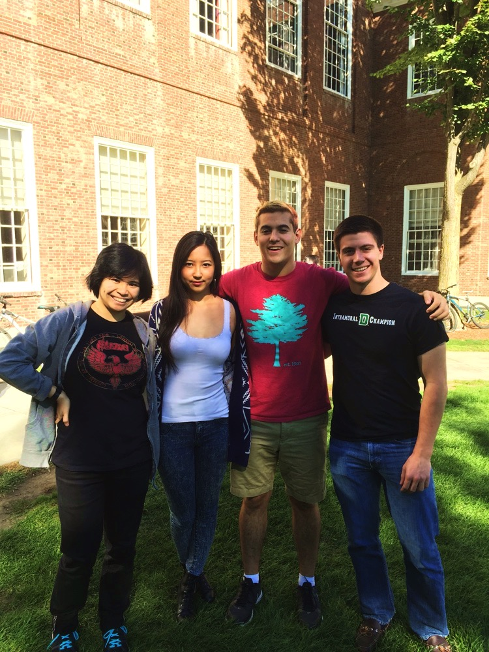

**Chris Leech**

|  |  |
| --- | --- |
| Languages | Java, Javascript, NodeJS, AngularJS, C, Bash |
| Experience | Software Development experience in CS50, and web dev experience from internship this summer and independent projects. |
| GitHub | chrisleech |

**Naho Kitade**

|  |  |
| --- | --- |
| Languages | Java, C, Python, Matlab, Android, Javascript, HTML/CSS, Bash, C++ |
| Experience | Internships with Google using Places API and Google Maps. Have an understanding of developing mobile and web apps. Interested in working on backend work. |
| GitHub | nahokitade |

**Matt Krantz**

|  |  |
| --- | --- |
| Languages | Java, Python, C, Bash, Android |
| Experience | Software development experience in the classroom (CS 50, 60, 65), experience in full-stack development as an intern at Delphix (mostly in Java). |
| GitHub | mlkrantz |

**Gloria Li**

|  |  |
| --- | --- |
| Languages | Java, C, Python, Javascript, NodeJS, HTML/CSS |
| Experience | Internships using JS to visualize data, building web databases, and service-to-service communication. Software implementation via CS50 and Android programming via CS65. |
| GitHub | gloli |